Computer Networks

Lab Task #10

Saad Ahmad

20P-0051

**Task#1**

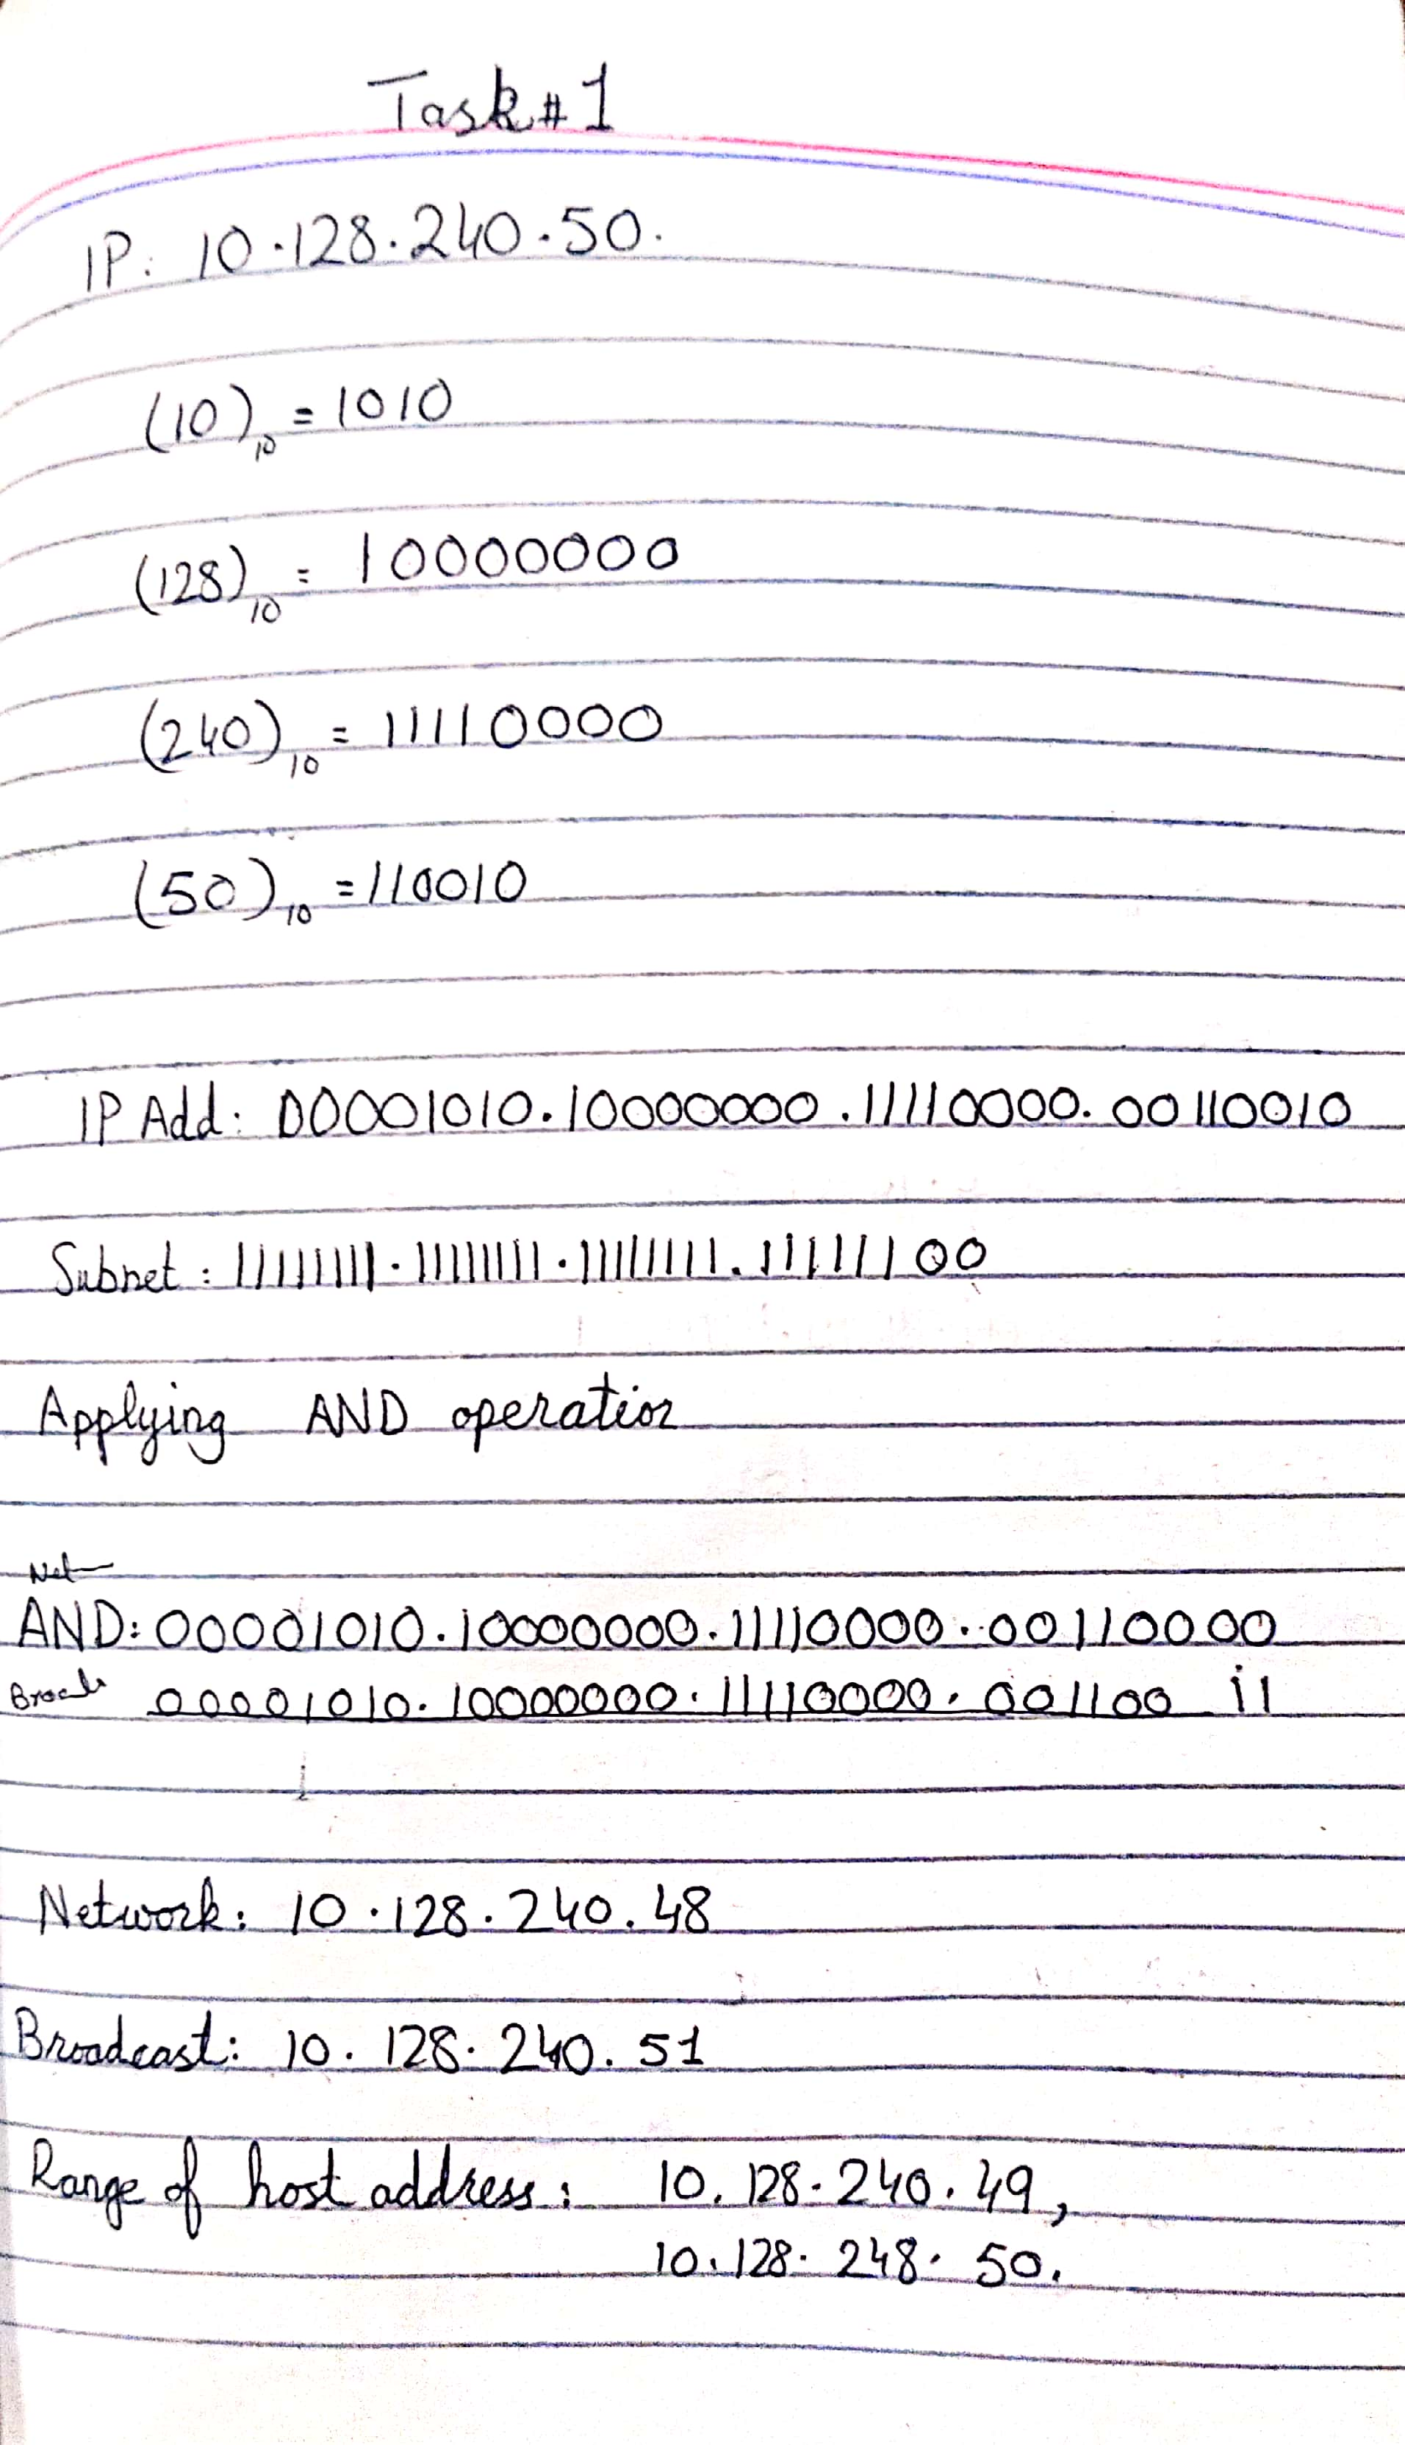

**Task #2**

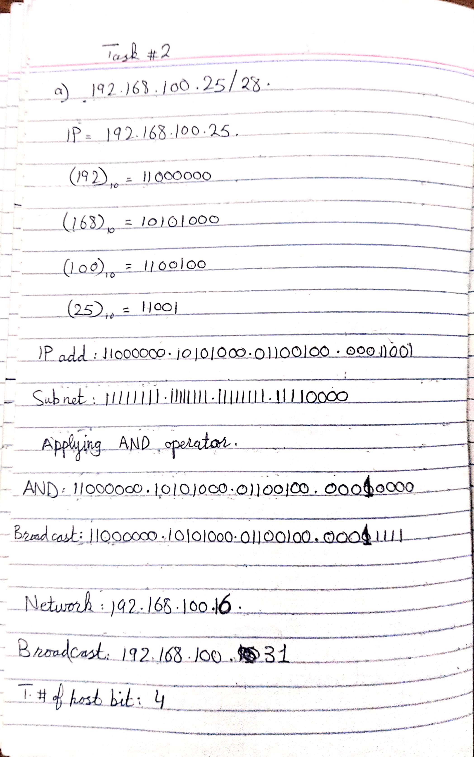

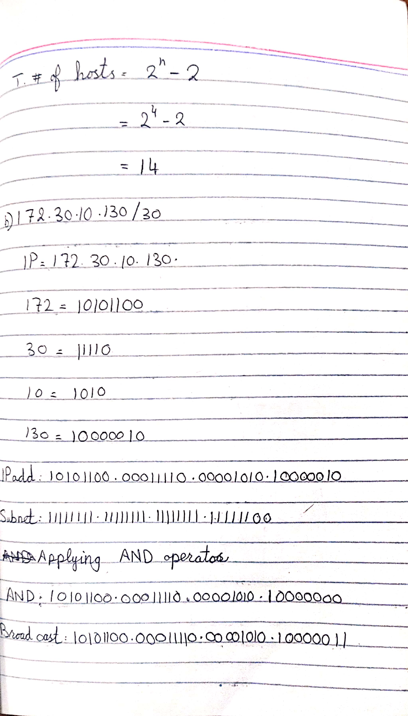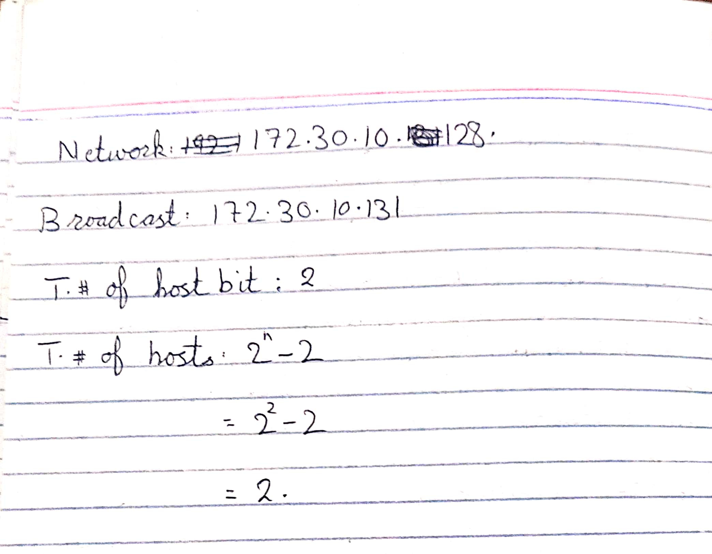

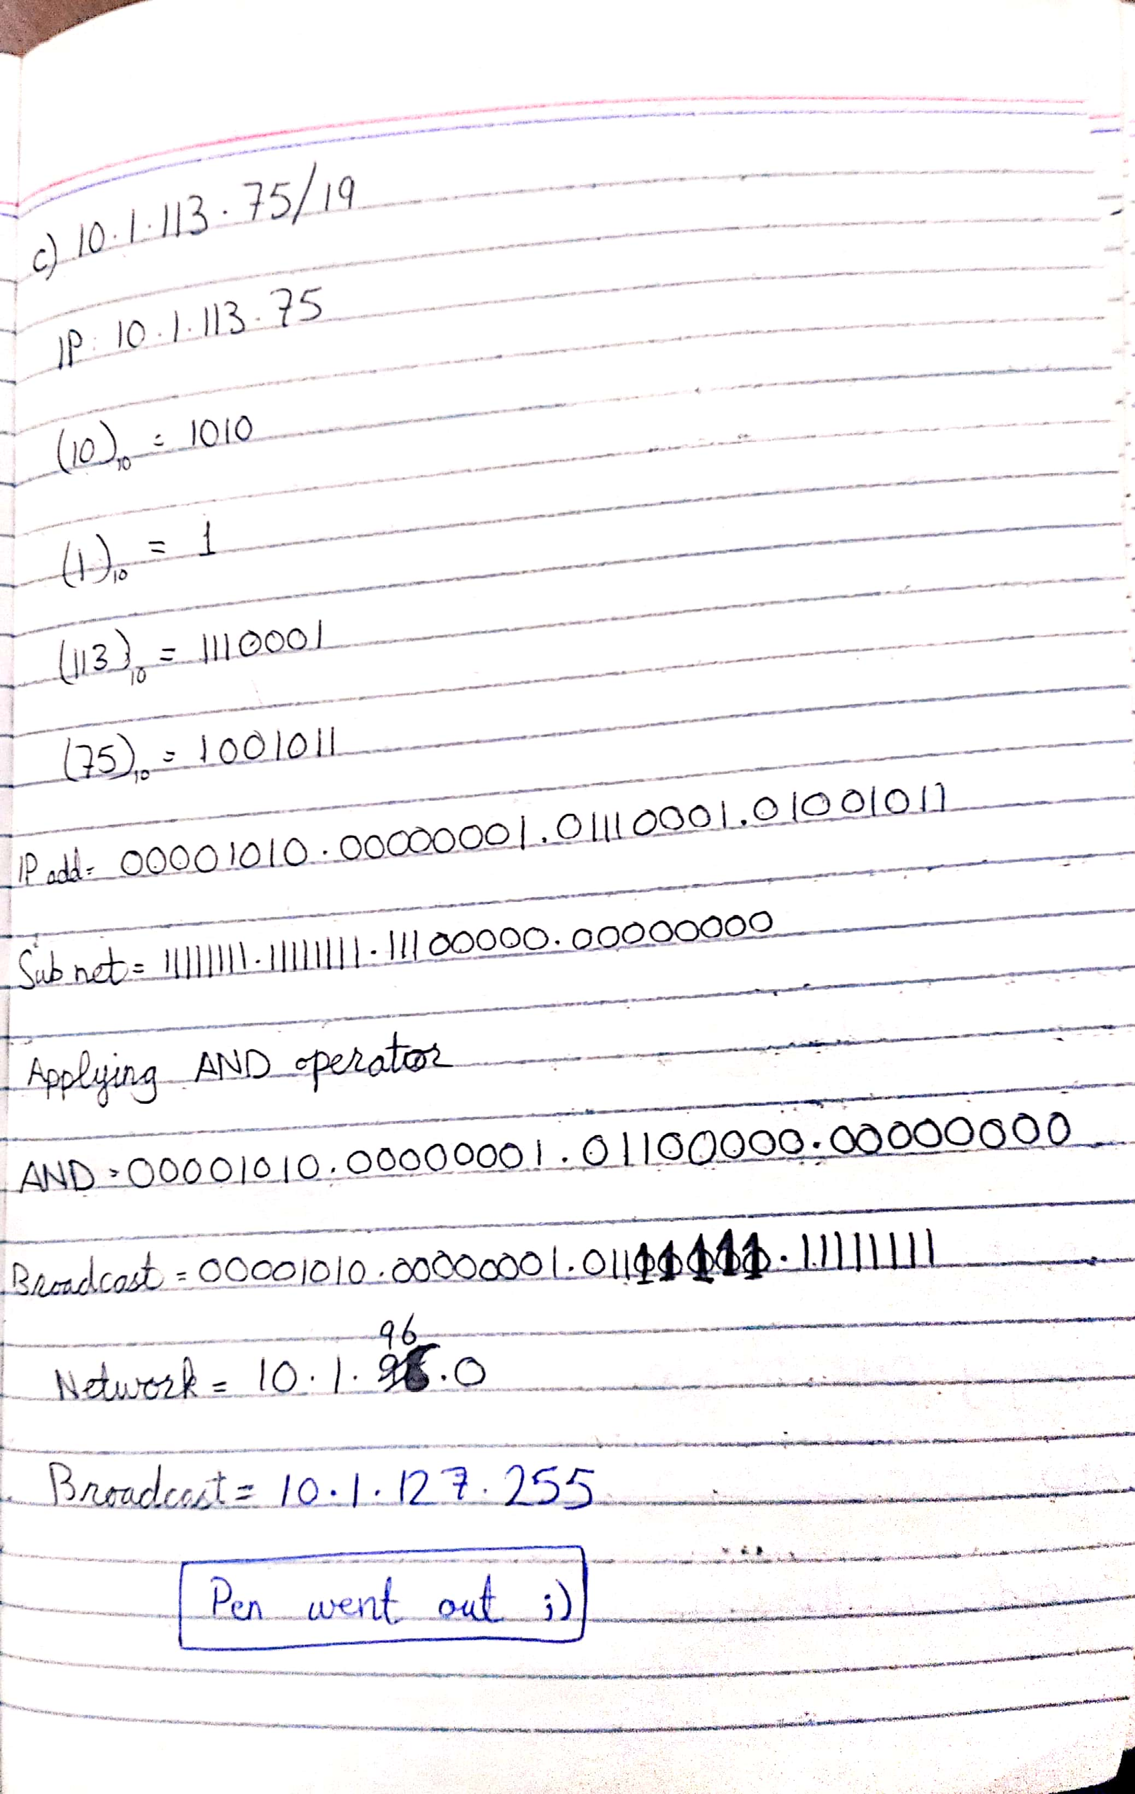

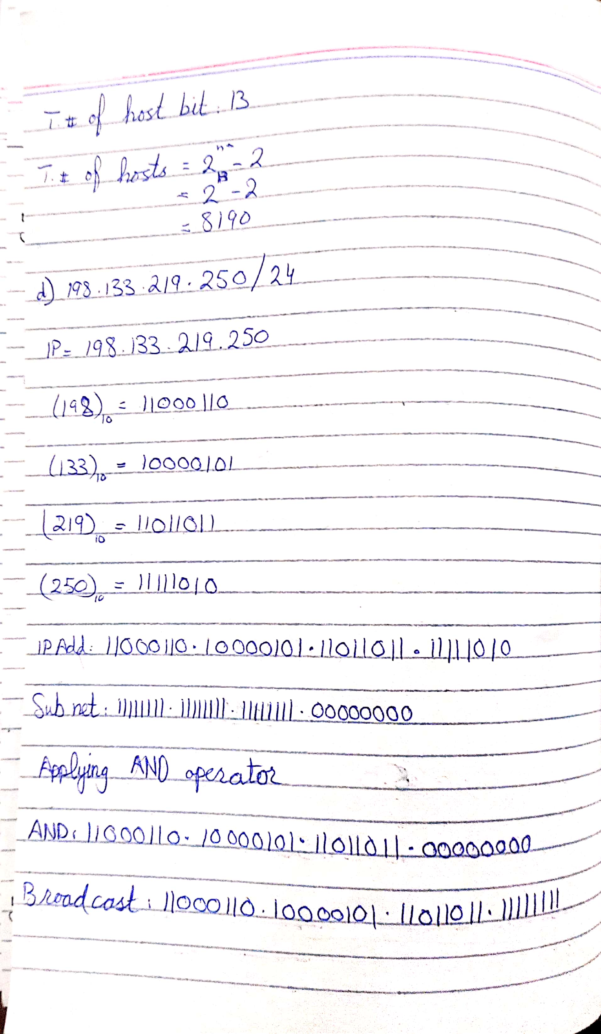

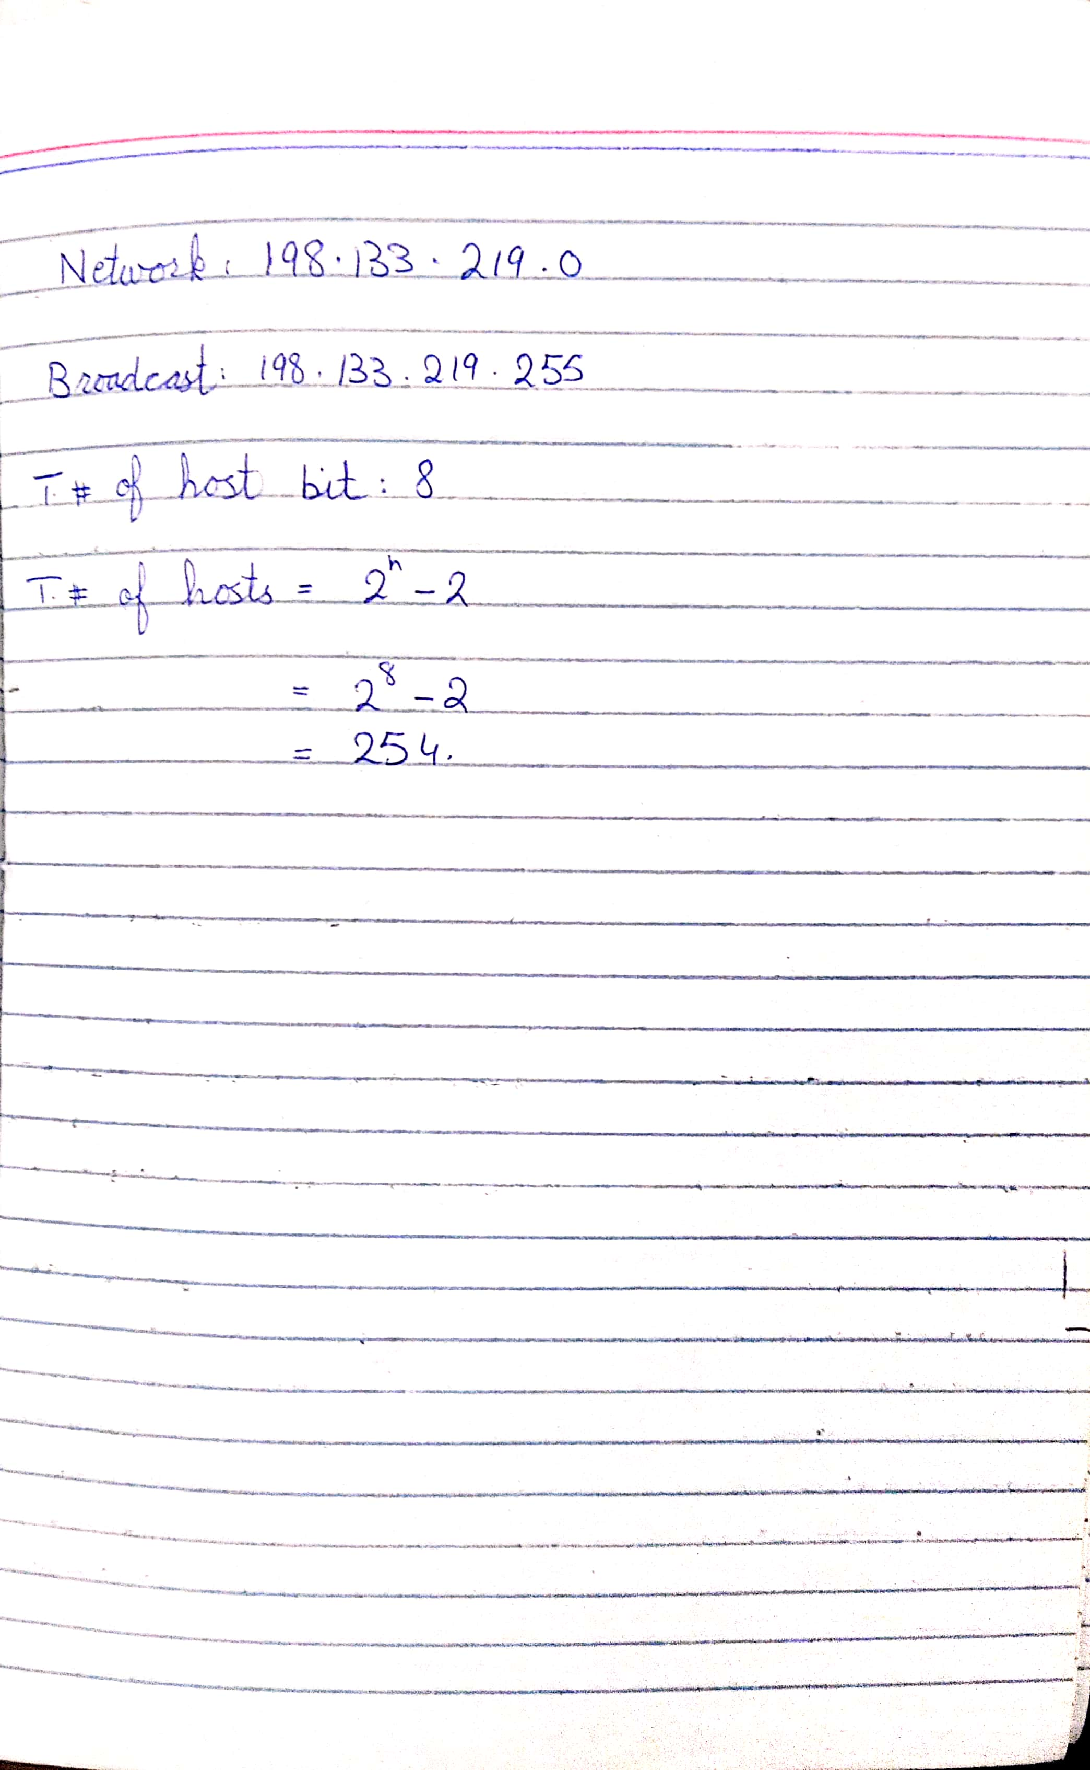

|  |  |  |  |  |
| --- | --- | --- | --- | --- |
| **IPv4**  **Address/Prefix** | **Network Address** | **Broadcast Address** | **Total Number of Host Bits** | **Total Number of Hosts** |
| **192.168.100.25/28** | 192.168.100.16 | 192.168.100.31 | 4 | 14 |
| **172.30.10.130/30** | 172.30.10.128 | 172.30.10.131 | 2 | 2 |
| **10.1.113.75/19** | 10.1.96.0 | 10.1.127.255 | 13 | 8190 |
| **198.133.219.250/24** | 198.133.219.0 | 198.133.219.255 | 8 | 254 |

**Task #3**

**Step 1: Determine the number of subnets in Network Topology A.**

1. How many subnets are there? 2
2. How many bits should you borrow to create the required number of subnets? 1
3. How many usable host addresses per subnet are in this addressing scheme? 126
4. What is the new subnet mask in dotted decimal format? 255.255.255.128
5. How many subnets are available for future use? _____0______

**Step 2: Record the subnet information.**

Fill in the following table with the subnet information:

|  |  |  |  |  |
| --- | --- | --- | --- | --- |
| **Subnet Number** | **Subnet Address** | **First Usable Host Address** | **Last Usable Host Address** | **Broadcast Address** |
| 0 | 192.168.10.0 | 192.168.10.1 | 192.168.10.126 | 192.168.10.127 |
| 1 | 192.168.10.128 | 192.168.10.129 | 192.168.10.254 | 192.168.10.255 |
| 2 |  |  |  |  |

**Task #4**

**Step 1: Determine the number of subnets in Network Topology B.**

1. How many subnets are there? 6
2. How many bits should you borrow to create the required number of subnets? 3
3. How many usable host addresses per subnet are in this addressing scheme? 30
4. What is the new subnet mask in dotted decimal format? 255.255.255.224
5. How many subnets are available for future use? 2

**Step 2: Record the subnet information.**

Fill in the following table with the subnet information:

|  |  |  |  |  |
| --- | --- | --- | --- | --- |
| **Subnet Number** | **Subnet Address** | **First Usable Host Address** | **Last Usable Host Address** | **Broadcast Address** |
| 0 | 192.168.10.0 | 192.168.10.1 | 192.168.10.30 | 192.168.10.31 |
| 1 | 192.168.10.32 | 192.168.10.33 | 192.168.10.62 | 192.168.10.63 |
| 2 | 192.168.10.64 | 192.168.10.65 | 192.168.10.94 | 192.168.10.95 |
| 3 | 192.168.10.96 | 192.168.10.97 | 192.168.10.126 | 192.168.10.127 |
| 4 | 192.168.10.128 | 192.168.10.129 | 192.168.10.158 | 192.168.10.159 |
| 5 | 192.168.10.160 | 192.168.10.161 | 192.168.10.190 | 192.168.10.191 |
| 6 | 192.168.10.192 | 192.168.10.193 | 192.168.10.222 | 192.168.10.223 |
| 7 | 192.168.10.224 | 192.168.10.225 | 192.168.10.254 | 192.168.10.255 |
| 8 |  |  |  |  |

**Step 3: Assign addresses to network devices in the subnets.**

a. Fill in the following table with IP addresses and subnet masks for the router interfaces:

|  |  |  |  |
| --- | --- | --- | --- |
| **Device** | **Interface** | **IP Address** | **Subnet Mask** |
| R1 | GigabitEthernet 0/1 | 192.168.10.1 | 255.255.255.224 |
|  | Serial 0/0/0 | 192.168.10.33 | 255.255.255.224 |
|  | Serial 0/0/1 | 192.168.10.65 | 255.255.255.224 |
| R2 | GigabitEthernet 0/1 | 192.168.10.97 | 255.255.255.224 |
|  | Serial 0/0/0 | 192.168.10.34 | 255.255.255.224 |
|  | Serial 0/0/1 | 192.168.10.129 | 255.255.255.224 |
| R3 | GigabitEthernet 0/1 | 192.168.10.161 | 255.255.255.224 |
|  | Serial 0/0/0 | 192.168.10.66 | 255.255.255.224 |
|  | Serial 0/0/1 | 192.168.10.130 | 255.255.255.224 |